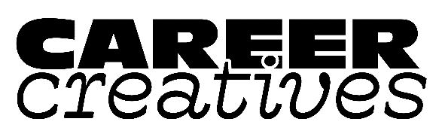

|  |
| --- |
| CareerCreatives.org |
| Certificate of Authenticity (COA) |
| A Certificate of Authenticity (COA) is a simple page or half-page which clarifies the piece of art you have created.  At a minimum, COAs provide artist name, title, dimensions, medium, and year completed. A more complex COA provides additional information like copyright, safe display instructions, artist signature, image, reproduction & edition information (for prints), and any additional information about the artwork you may wish to provide.  The COA is not required, but is a great addition to any piece you sell – original or reproduction. This ensures for your collector that the piece they have purchased is in fact your work, and also provides the beginning point of any artwork’s provenance (its lineage). A steady practice of using COAs with each work will also help prevent copyright infringements and possible disagreements about “knock offs.”  As you can see, COAs are not required to sell work, but add another layer of protection to your intellectual property, and help collectors feel they have made a sound investment choice. And it’s another take-away you can pack with orders – along with swag and promos.   * Use this COA for your art prints. Indicate whether the run is limited and other key information to let collectors know the value in their artist print. Be sure to fill out appropriate information in the top & bottom paragraphs. * Complete all indicated information *except* for signature & print numbers, then print one copy for each print, and complete manually for each print number. |

# Certificate of Authenticity

This certifies that the print “*[ARTWORK TITLE]*” is an authentic limited edition giclée print made from an oil painting by [ARTIST NAME]. This giclée was meticulously matched to the original painting in a cooperative effort between the artist and printer to attain a print that faithfully captures the essence of the original and has been inspected for color accuracy by the artist before being signed. This print is number ___________ out of an edition size of *{Input number}.*

Number in Edition:

Original Medium:

Method of Reproduction: {giclée}

Maximum in Edition:

Artist Proof:

Paper Information:

Ink Information: {Archival pigment-based inks of museum quality}

Image Size:

Publisher:

The artist represents that this edition is limited to *[HOW MANY #]* and is available in the image size of *{IMAGE SIZE}.* No further reproduced giclée prints of the original will be made at any size, or by any other reproduction method to the general public, or other organizations. The buyer of this artwork is guaranteed that the artist will adhere to these standards and that the printmaker will act in accordance to the artist or artist’s representative’s direction I providing these limited edition prints. The artist retains the sole copyright of the original painting. Any unauthorized reproduction is in violation of U.S. copyright law. All information and statements contained herein are true and correct.

Artist’s Signature _____________________________________

ARTIST NAME

ARITST EMAIL/SOCIAL

WEBSITE

ADDRESS/PHONE