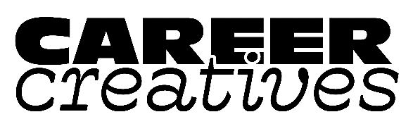

|  |
| --- |
| CareerCreatives.org |
| Certificate of Authenticity (COA) |
| A Certificate of Authenticity (COA) is a simple page or half-page which clarifies the piece of art you have created.  At a minimum, COAs provide artist name, title, dimensions, medium, and year completed. A more complex COA provides additional information like copyright, safe display instructions, artist signature, image, reproduction & edition information (for prints), and any additional information about the artwork you may wish to provide.  The COA is not required, but is a great addition to any piece you sell – original or reproduction. This ensures for your collector that the piece they have purchased is in fact your work, and also provides the beginning point of any artwork’s provenance (its lineage). A steady practice of using COAs with each work will also help prevent copyright infringements and possible disagreements about “knock offs.”  As you can see, COAs are not required to sell work, but add another layer of protection to your intellectual property, and help collectors feel they have made a sound investment choice. And it’s another take-away you can pack with orders – along with swag and promos.   * For this half-page COA, be sure to cut along center line, and safely glue to the back of your work. |

Certificate of Authenticity

This certifies that this piece of art identified herein is an original, authentic work produced by the artist. This piece has been hand-signed by the artist. All copyright and reproduction rights to the work are fully retained by the artist.

Title of Artwork __________________________________________________________

Artist’s Name ____________________________________________________________

Dimensions ______________________________________________________________

Date completed ___________________________________________________________

Medium _________________________________________________________________

­­­­___________________________________________________________________

Signature of Artist

Certificate of Authenticity

This certifies that this piece of art identified herein is an original, authentic work produced by the artist. This piece has been hand-signed by the artist. All copyright and reproduction rights to the work are fully retained by the artist.

Title of Artwork __________________________________________________________

Artist’s Name ____________________________________________________________

Dimensions ______________________________________________________________

Date completed ___________________________________________________________

Medium _________________________________________________________________

­­­­Signature of Artist